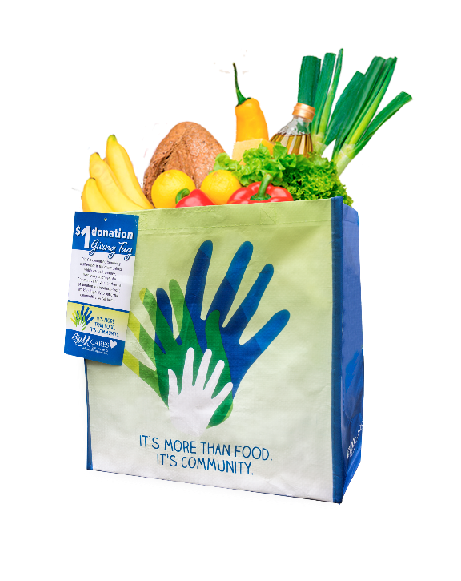
COMMUNITY BAG PROGRAM

Sample Email

DOWNLOAD IMAGES

SUBJECT LINE: We’ve been selected by the Big Y Community Bag Program!

PREVIEW TEXT: For all of [Month] every reusable Community Bag purchased at Big Y earns us
$1!

Dear [Staff/Board/Volunteers],

We are so excited to share that [organization] has been selected to benefit from Big Y’s Community Bag Program, which makes it easy for customers to contribute to their local communities.

For the month of [month], whenever a $2.50 reusable Community Bag is purchased at the Big Y located at [location], $1 will be donated to [organization]. This is a great way to broaden awareness and help our cause.

Let’s get started! Share the news with friends and family. Call, send emails and post on social media. The more people who purchase the Community Bag in [month], the more we can raise!
To learn more about this program, please visit bigy.2givelocal.com.
Best,
[Signature]

bigy.2givelocal.com

