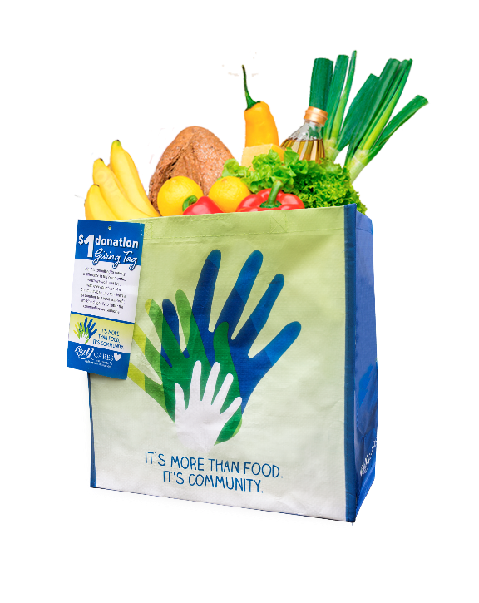
COMMUNITY BAG PROGRAM

Announcement Email

SUBJECT LINE: We’ve been selected by the Big Y Community Bag Program!

PREVIEW TEXT: During [Month], we receive $1 for every reusable Community Bag purchased at Big Y!

Dear [Staff/Board/Volunteers/Supporters],

We are so excited to share that, for the entire month of [month], [organization] has been selected by store leadership to benefit from Big Y’s Community Bag Program, which makes it easy for shoppers to contribute to their local communities.

Whenever a $2.50 reusable Community Bag is purchased at the Big Y located at [location] in [month], $1 will be donated to [organization]. This is a great way to broaden awareness and help our cause. More than $420,000 has been donated to almost 1,900 nonprofit organizations since the program launched in January 2019.

Let’s get started! Share the news with friends and family. Call, send emails, and post on social media. The more people who purchase the Community Bag in [month], the larger the donation we will receive!
To learn more about this program, please visit bigy.2givelocal.com.
Best,
[Signature]

