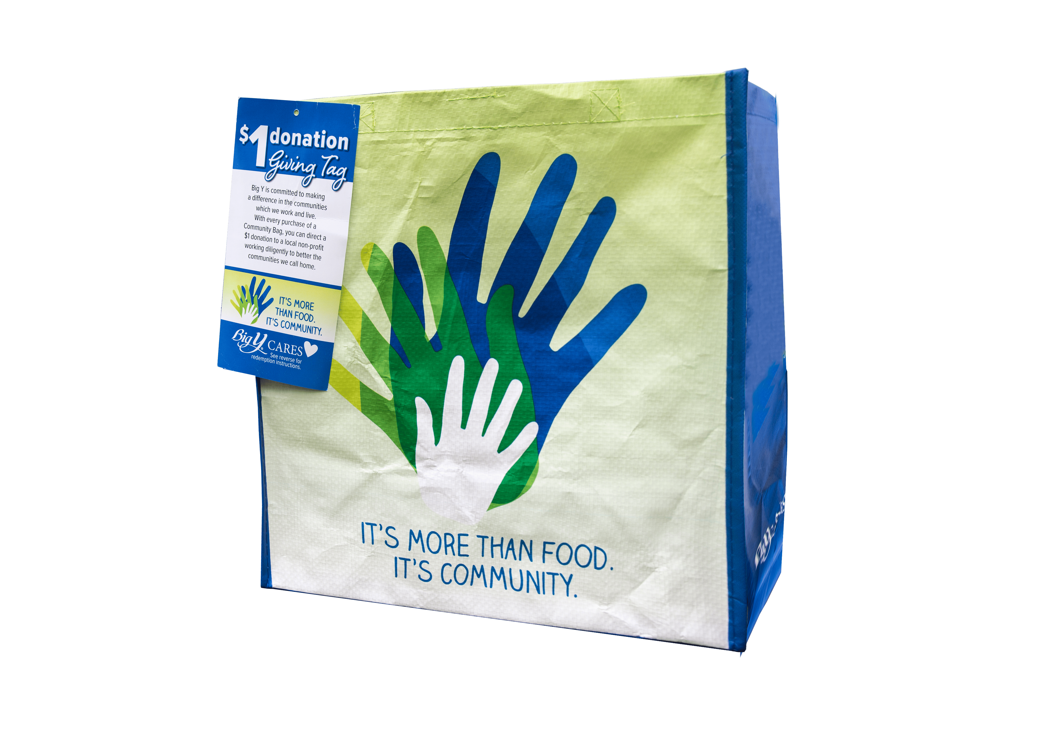



**COMMUNITY BAG PROGRAM**

Announcement Email

& Social Post

**SUBJECT LINE:** We’ve been selected to partner with the Big Y Community Bag Program!

**PREVIEW TEXT:** During [*Month*], we receive $1 for every reusable Community Bag purchased at our selected Big Y location!

Dear [*Staff/Board/Volunteers/Supporters*],

We are excited to share that Big Y has selected [*organization*] to benefit from the Community Bag Program throughout [*month*]. The Big Y Community Bag Program makes it easy for shoppers to contribute to their local communities.

Every time a $2.50 reusable Community Bag is purchased at the Big Y located at [*location*] in [*month*], $1 will be donated to [*organization*]. This is a great way to broaden awareness of our mission and help our cause.

Let’s get started! Share the news with friends and family. Call, send emails, and post on social media. The more people who purchase a Community Bag in [*month*], the greater the donation we will receive from Big Y!

For more information about this program, please visit [bigy.2givelocal.com](https://bigy.2givelocal.com).

Best,

[*Signature*]



**Share With Your Followers**

**We’re excited that the Store Leadership Team at Big Y selected our organization to benefit from the Community Bag Program! Throughout [*month*], we will receive a $1 donation for every $2.50 reusable Community Bag purchased at the Big Y located at [*address of selected store(s)*].**