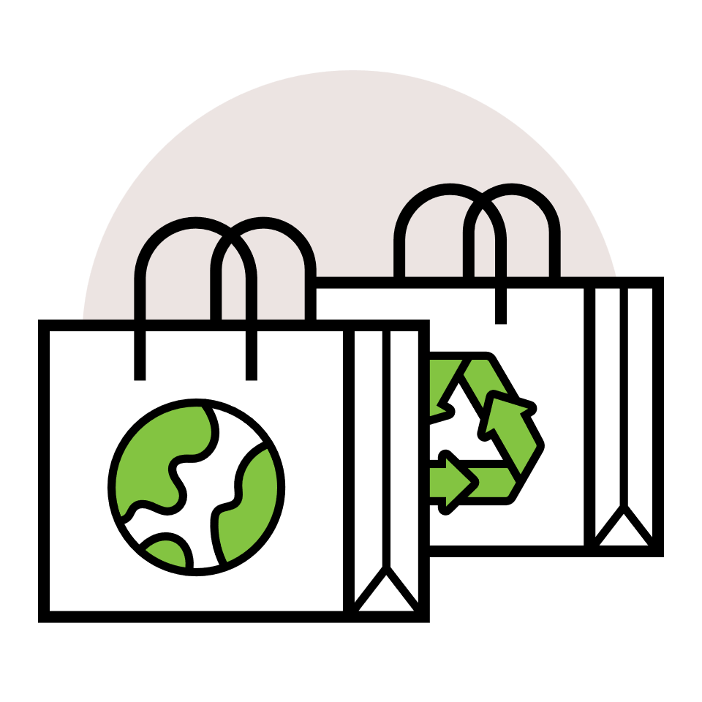

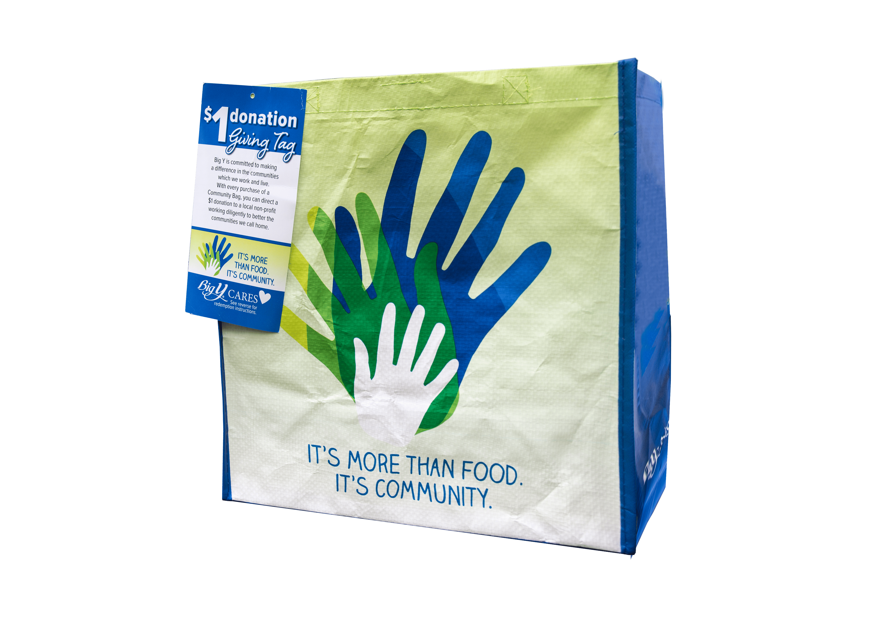

COMMUNITY BAG PROGRAM

Launch Day Email

& Social Post

**SUBJECT:** Launch day for the Big Y Community Bag Program partnership!

**PREVIEW TEXT:** Our partnership with the Big Y Community Bag Program starts today.

Good morning,

Today is the launch day for our Big Y Community Bag Program partnership! Throughout [*month*], when you purchase a reusable Community Bag for $2.50 at the Big Y(s) located at [*address(es) of selected store(s)*], $1 will be donated to [*name of organization*].

During this monthlong partnership, our goal is to sell [*goal of bags bought, e.g., 200*] bags, which is equivalent to $[*insert donation equivalent, e.g., $200*] donated. We are confident that with the help of our dedicated supporters we can reach this goal.

To make the most of this opportunity, we strongly encourage you to share this news with your friends and family. Make sure everyone knows to look for Community Bags on display racks in our selected store(s) this month.

For more information about this program, please visit [bigy.2givelocal.com](https://bigy.2givelocal.com).

Thank you for your support!

Best,

[*Signature*]



Share With Your Followers

**Today, we start benefiting from the Big Y Community Bag Program! This month, our organization will receive a $1 donation for every $2.50 reusable Community Bag purchased at the Big Y(s) located at [*store* *address(es)*].**