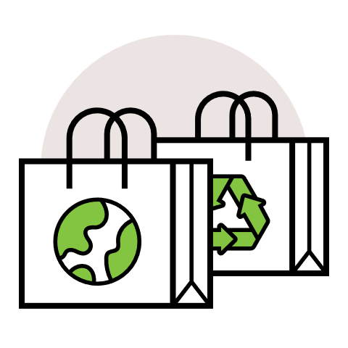
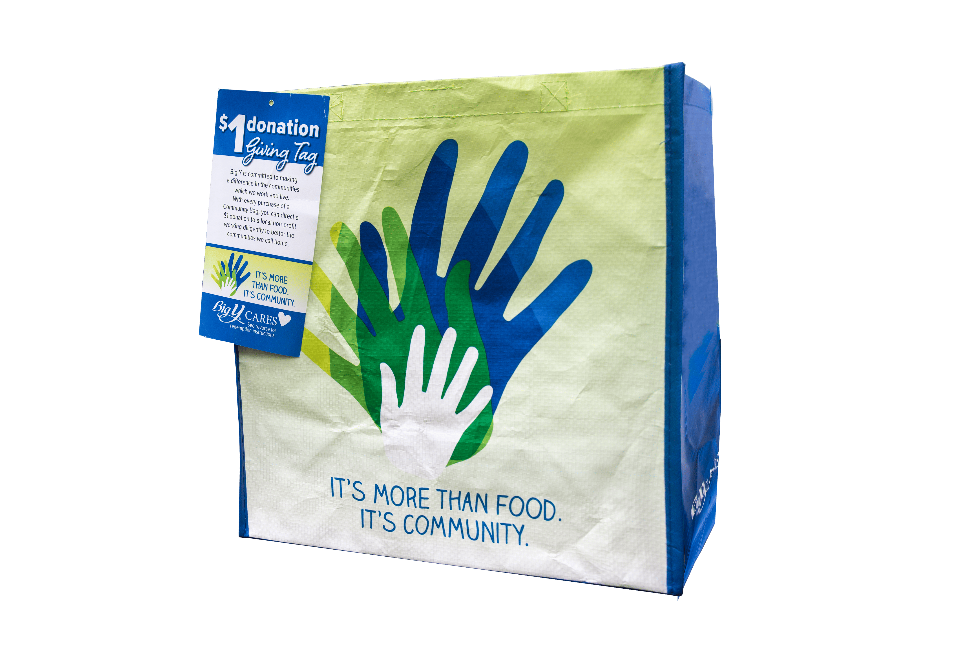

COMMUNITY BAG PROGRAM

Reminder Email

SUBJECT: We have [insert number of weeks or other time frame] weeks remaining in our Big Y Community Bag Program partnership!
PREVIEW TEXT: There’s still time to maximize this opportunity for our cause!

Good morning,
We've reached [or We will shortly reach] the halfway point in our [insert month] partnership with the Big Y Community Bag Program. This is a wonderful opportunity to raise funds for our organization and to spark positive change in our community!
Remember, for every $2.50 Big Y reusable Community Bag purchased at [insert location] this month, we'll receive $1. Every bag counts, so let's maximize this opportunity!
Please spread the word to your friends and family. Let's encourage everyone to look for the Big Y Community Bags in our selected store(s) this month. There’s still time left to make a difference!
For more information about this impactful program, please visit bigy.2givelocal.com.
Thank you for your support!
Best,
[Signature]

