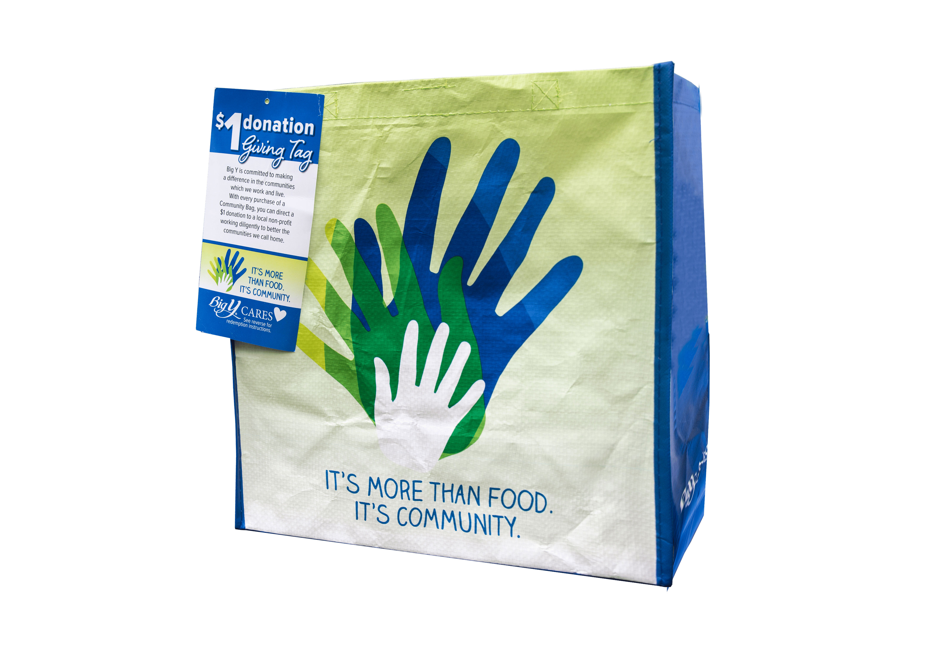

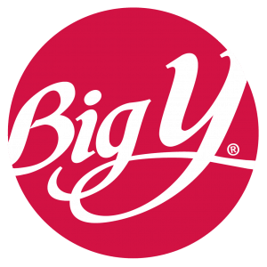

Announcement Email

SUBJECT LINE: We’ve been selected to partner with the Big Y Community Bag Program!
PREVIEW TEXT: Every Community Bag sold at our Big Y location(s) during [month] = $1 for [organization].

Dear [Staff/Board/Volunteers/Supporters],

We’re excited to share that Big Y has selected [organization] to benefit from their
Community Bag Program during [month]! This program not only promotes sustainability by
reducing plastic waste but also provides a meaningful opportunity to grow awareness and
support for our mission within the community.

Here’s how it works:
For every $2.50 reusable Community Bag purchased at:
[store address(es)]
$1 is directed to [organization].

It’s that simple, and it adds up fast. Each bag purchased is a small action that helps us continue to [brief mission impact, e.g., “provide meals,” “support families,” “serve our community”].

If you’re able, please help spread the word:

- Share with friends and family.
- Post on social media.
- Mention it the next time you connect with someone.

The more bags purchased, the greater the impact we can make together. Thank you for helping turn everyday shopping into meaningful support for our mission!

With gratitude,
[Signature]

